Ionic Nomenclature
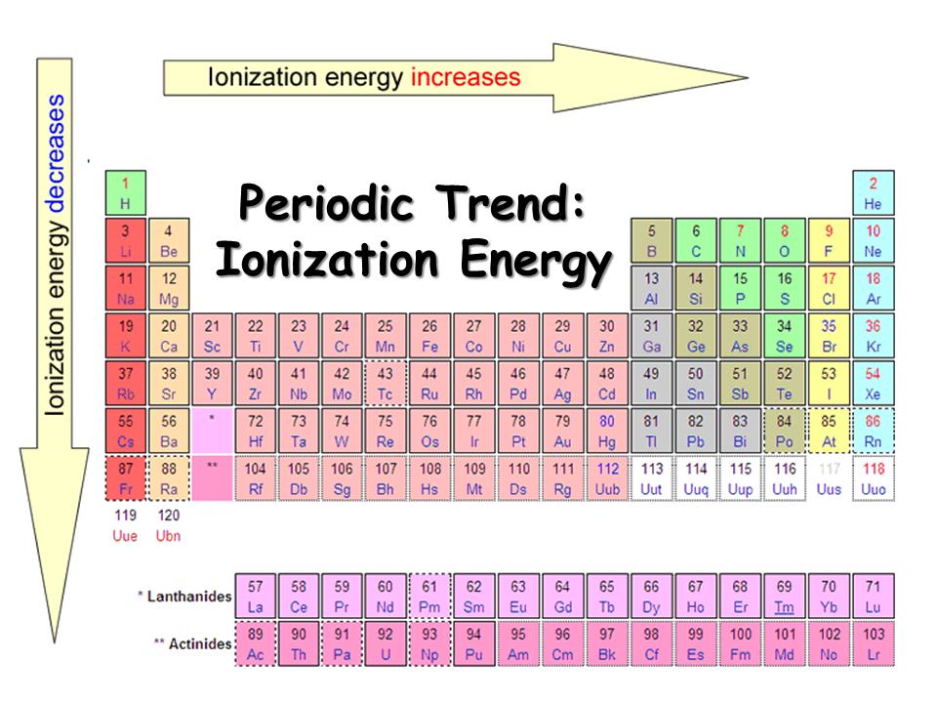

Consider the following list of elements: Lithium, Bromine, Nitrogen, Calcium, Potassium, Phosphorous, Oxygen, Sulfur, Magnesium, Sodium, and Aluminum

1. List the elements (from above) that can form cations easily, and list the charge you would expect with these cations:
Lithium = +1, Calcium = +2, Potassium = +1, Magnesium = +2, Sodium = +1, Aluminum = +3

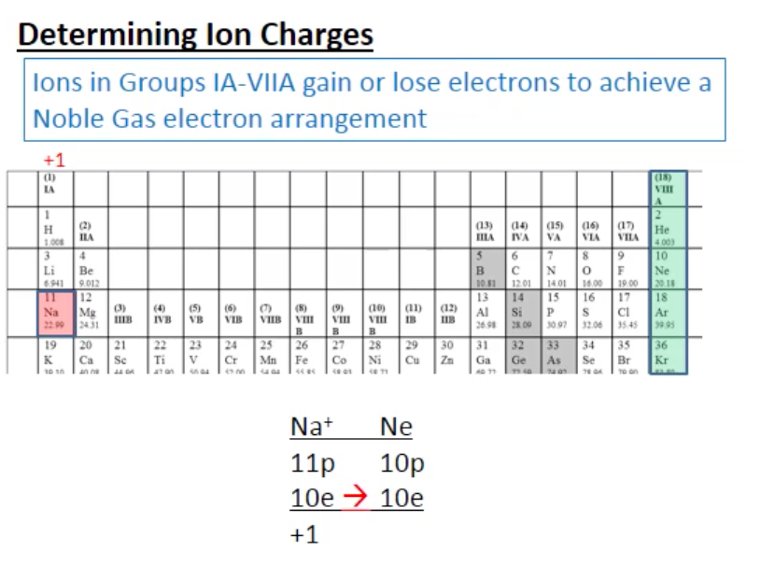
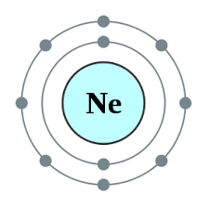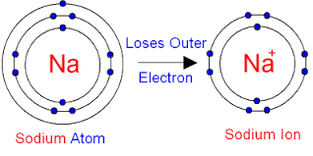

2. List the elements (from above) that can form anions easily, and list the charge you would expect with these anions:
Bromine = -1, Nitrogen = -3, Phosphorous = -3, Oxygen = -2, Sulfur = -2

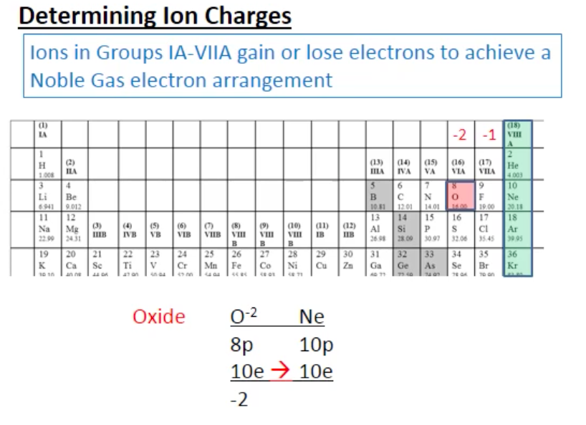

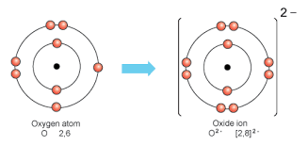

3. Write the formula, and name for ionic compounds formed from:
Na&S = Na₂S (Sodium Sulfide) K&Br = KBr
(Potassium Bromide)

Ca&P = Ca₃P₂ (Calcium Phosphide) Al&F = AlF₃ (Aluminum Fluoride)

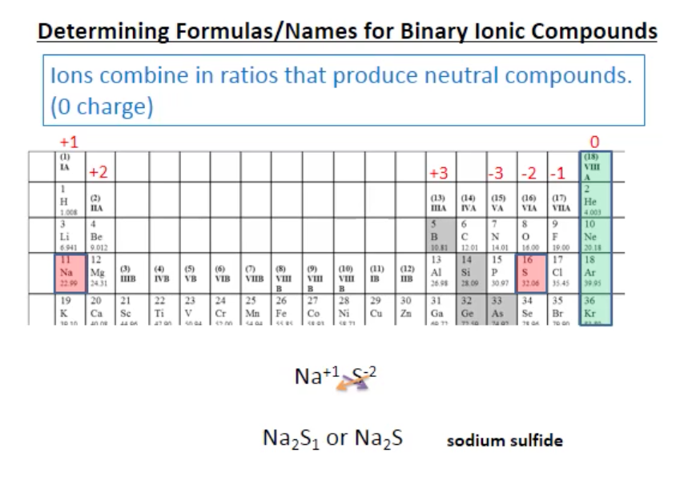

4. Write names for the following compounds:
NiS Nickel(II) Sulfide Cr₂O₃ Chromium(III) Oxide

Each O is 2- making 6-.
So 6+ divided by the 2 Cr is 3+
CuCl₂ Copper(II) Chloride Hg₂Cl₂ Mercury(I) Chloride

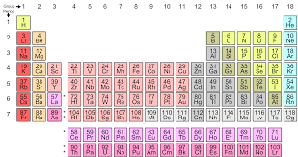

5. Name the following compounds with polyatomic ions:

CaCO₃ Calcium Carbonate KNO₃ Potassium Nitrate

NaHCO₃ Sodium Hydrogencarbonate Al(NO₃)₃ Aluminum Nitrate
(or Sodium Bicarbonate)
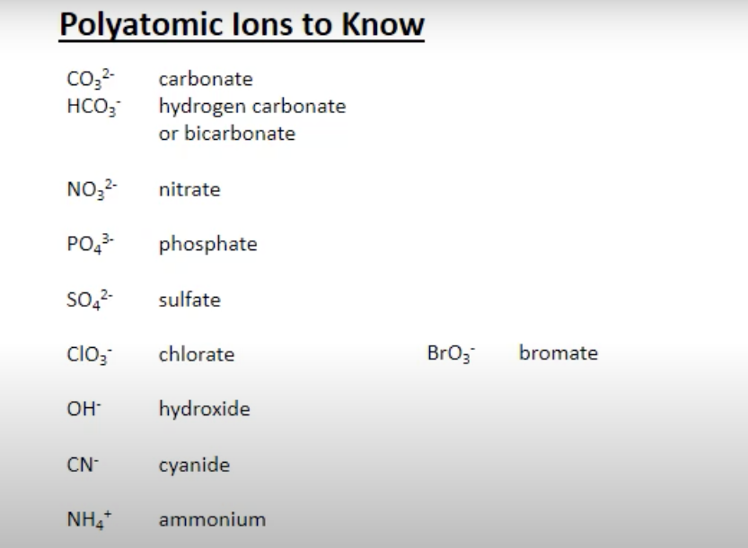

Covalent Nomenclature

1. Supply Greek prefixes for the following numbers:

one: mono two: di three: tri

four: tetra five: penta six: hexa

seven: hepta eight: octa nine: nona

ten: deca

2. An easy way to spot ionic compounds:
Metal + nonmetal (KBr), metal + polyatomic anion (CaSO₄), polyatomic anion + polyatomic cation (NH₄NO₃), polyatomic cation + nonmetal (NH₄Cl)

3. An easy way to spot covalent (molecular) compounds: nonmetal + nonmetal(s)

4. Name the following compounds:

CaCl₂ Calcium chloride CO₂ Carbon dioxide

NO₂ Nitrogen dioxide SF₆ Sulfur hexafluoride

NaCl Sodium chloride PCl₃ Phosphorous trichloride

ICl₅ Iodine pentachloride H₂O Water

NH₃ Ammonia

5. Supply Chemical formulas for the following compounds:

Carbon tetrachloride CCl₄ Copper(II) Sulfate CuSO₄
Formulas and Names of Common Ions
 | Metals |  |  | Nonmetals
Group Number | Cation | Name of Cation | Group Number | Anion | Name of Anion
1A | Li⁺ | Lithium | 5A | N³⁻ | Nitride
 | Na⁺ | Sodium |  | P³⁻ | Phosphide
 | K⁺ | Potassium | 6A | O²⁻ | Oxide
2A | Mg²⁺ | Magnesium |  | S²⁻ | Sulfide
 | Ca²⁺ | Calcium | 7A | F⁻ | Fluoride
 | Ba²⁺ | Barium |  | Cl⁻ | Chloride
3A | Al³⁺ | Aluminum |  | Br ⁻ | Bromide
 |  |  |  | I⁻ | Iodide

Metals That Form More Than One Positive Ion
Element | Possible Ions |  | Name of Ion
Chromium | Cr²⁺ |  | Chromium(II)
 | Cr³⁺ |  | Chromium(III)
Copper | Cu⁺ |  | Copper(I)
 | Cu²⁺ |  | Copper(II)
Mercury | Hg₂²⁺ |  | Mercury(I)*
 | Hg²⁺ |  | Mercury(II)
Nickel | Ni²⁺ |  | Nickel(II)
 | Ni³⁺ |  | Nickel(III)
*Mercury (I) ions form an ion pair with a 2+ charge
Names and Formulas of Some Common Polyatomic Ions
Nonmetal |  | Formula of Ion |  | Name of Ion
Hydrogen |  | OH⁻ |  | Hydroxide
Nitrogen |  | NH₄⁺ |  | Ammonium
 |  | NO₃⁻ |  | Nitrate
Chlorine |  | ClO₃⁻ |  | Chlorate
Carbon |  | CO₃²⁻ |  | Carbonate
 |  | HCO₃⁻ |  | Hydrogen carbonate (or bicarbonate)
Sulfur |  | SO₄²⁻ |  | Sulfate
Phosphorus |  | PO₄³⁻ |  | Phosphate

